

**T.C**

**Piri Reis University**

**Faculty of Economics and Administrative Sciences Management Information Systems**

**Assignment Report**

My Database Topic = Hotel Reservation

Student Name = Naci Eren

Student Surname = Kılıç

Date of Report = 29.05.2023

Lesson = ISE312 Data Structures and Databases

Department = Information Systems Engineering

University = Piri Reis University

**Heliotels Topic**

The purpose of my project is to book a hotel. In my project, the user must log in first. For this reason, especially the user names and passwords of the users, apart from these, many features such as year of birth, city where they live, gender are kept in our database. Then, our contracted hotels that are suitable for what they want are stored in our database, especially the prices and points, but also their locations, names and capacities are stored in our database. We store the credit cards that users use to purchase the hotel they have chosen for their next use in our database at their request. Which hotels the users stayed in after paying transactions are also included in our database.

**Relational** **Database** **Schema**

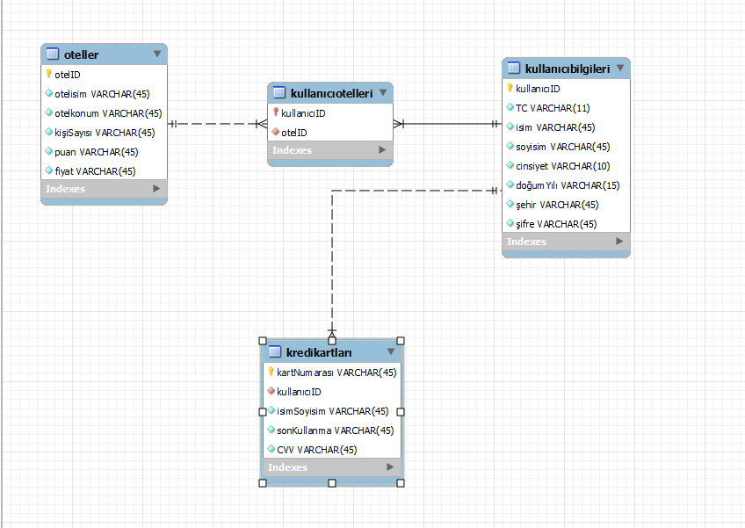

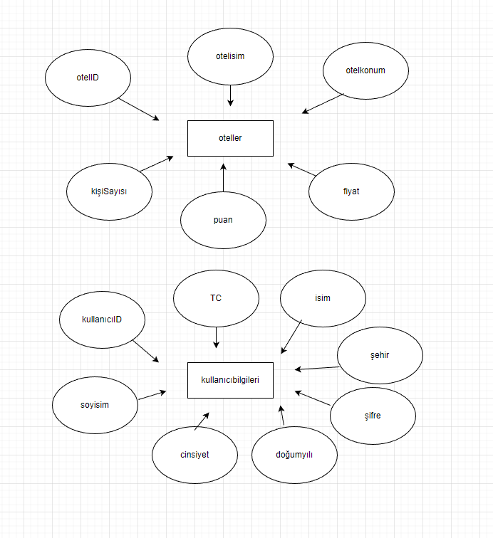

**Entity**

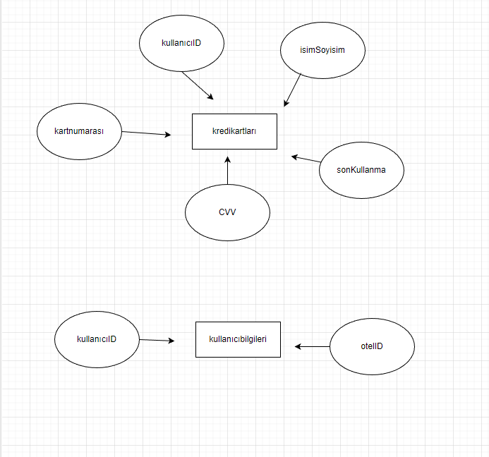

**Create the relations (tables) and data**

metin, ekran görüntüsü, yazı tipi, sayı, numara içeren bir resim

Açıklama otomatik olarak oluşturuldu**Table 1 – oteller**

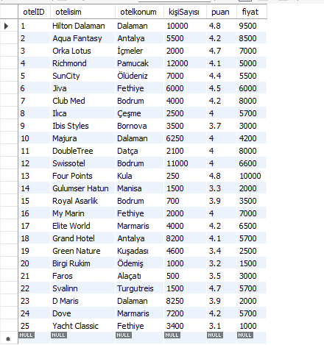

**Table 2 – kullanıcıbilgileri**

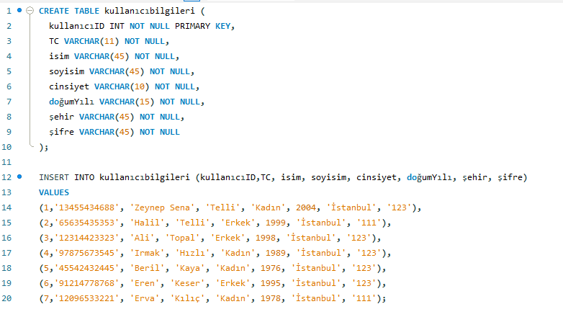

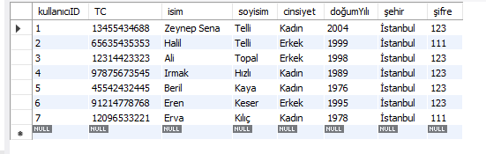

**Table 3 – kredikartları**

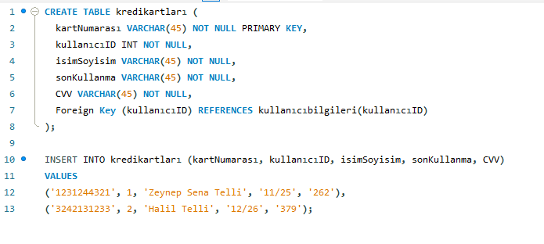

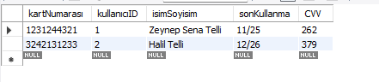

**Table 4 – kullanıcıotelleri**

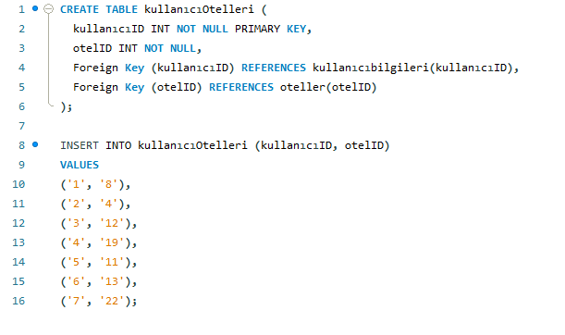

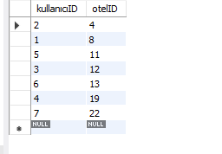

**General and Advanced Search Queries**

**General queries**

**1st Query**

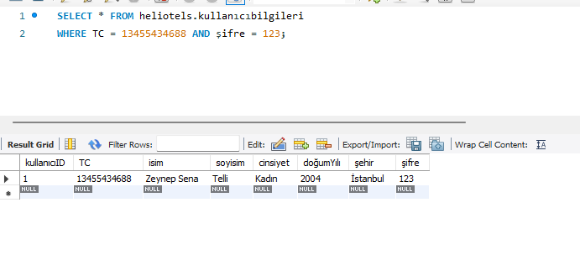

This query is for member login TC and password control.

**2nd Query**

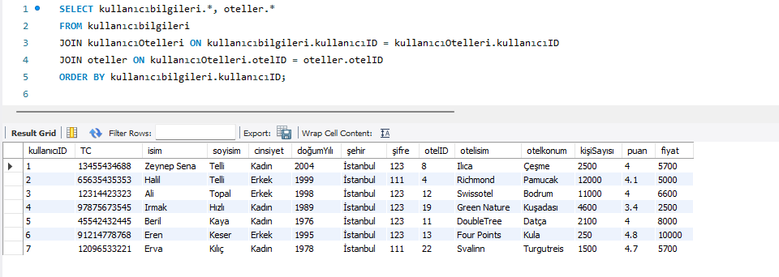

This query is used to find out which hotel users are staying at.

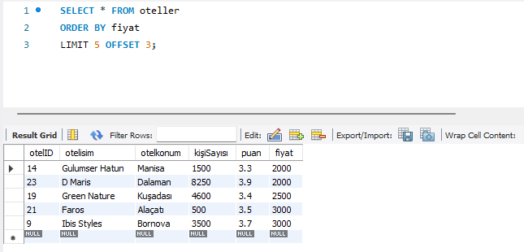 **3rd Query**

This query is to skip the cheapest 3 hotels and sort the prices of the next 5 hotels from the cheapest to the most expensive.

**Advanced queries**

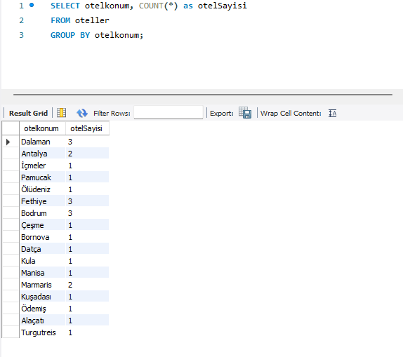 **1st Query**

This query is to find out how many hotels there are in which locations.

**2nd Query**

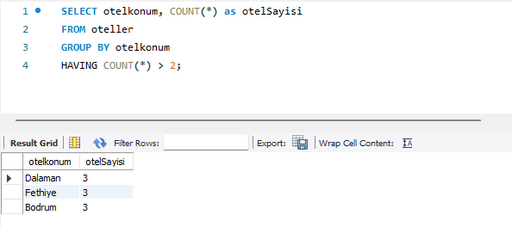

This query is used to find locations with more than 2 hotels.

**3rd Query**

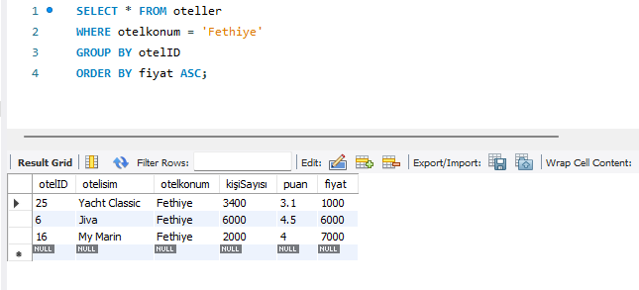

This query is for sorting the hotels in Fethiye from the cheapest to the most expensive.